**What can we do with IFC files in Civil Engineering (Bridge Context)?**

*(content of this note can be found in* [*https://github.com/CFCSL/BIM/blob/main/IFC/ifcModel.py*](https://github.com/CFCSL/BIM/blob/main/IFC/ifcModel.py)*)*

**1. Model Inspection & Metadata Extraction**

* Read all elements like **IfcBridge**, **IfcPier**, **IfcBeam**, **IfcColumn**, **IfcSlab**, etc.
* Extract **project metadata**:
  + Project name, author, creation date
  + Units, coordinate system
  + Version and schema (IFC4)
* Verify compliance with standards (e.g., ISO 19650).

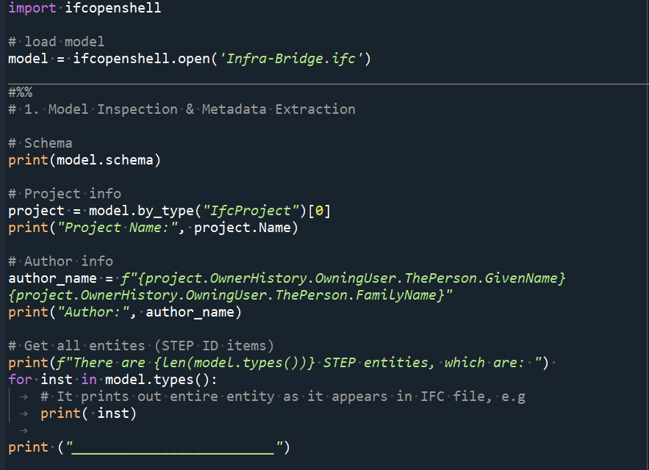

**2. Geometry & Spatial Analysis**

To extract geometric data (coordinates, vertices, faces) for structural elements, such as beams, for positioning and alignment verification.

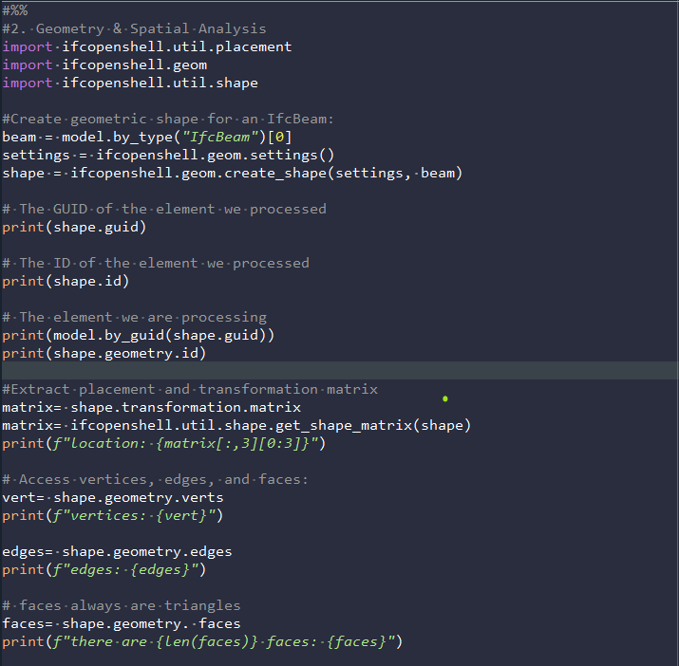

**3. Quantities & Material Take-off (QTO)**

* Extract **BaseQuantities** for:
  + **Length of girders and beams**
  + **Cross-sectional area**
  + **Volume of concrete** in decks, piers, foundations
* Perform **material estimation** for cost analysis or procurement.

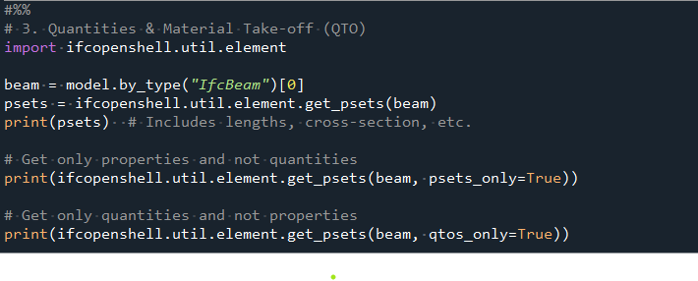

**4. Unit Conversion & Standardization**

* Convert project units to **SI** for analysis.
* Check **unit consistency** (meters vs. millimeters).

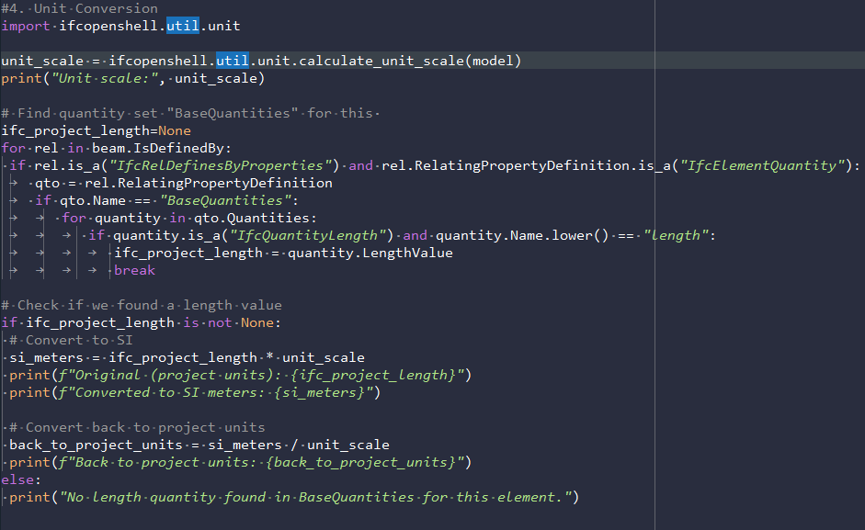

**5. Custom IFC File Generation**

* Create IFC from scratch for:
  + **New bridge designs**
  + **Partial models** (e.g., only beams for analysis)
* Copy or clone elements for **model simplification** or **what-if scenarios**.

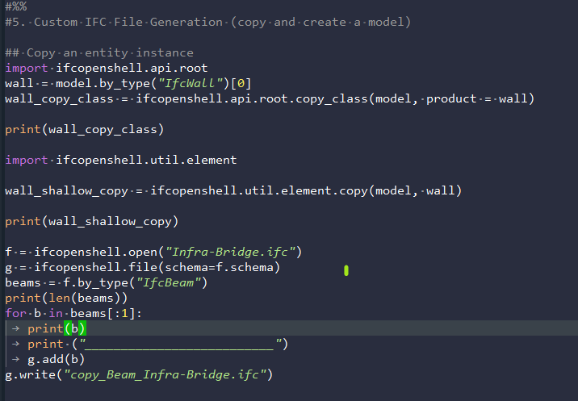

6. Extract a sample data from a file.ifc to excel, objects are group by name

See full link in GitHub: <https://github.com/CFCSL/BIM>

Source code: <https://github.com/CFCSL/BIM/blob/main/IFC/CodeExample.py>

Export data to excel: <https://github.com/CFCSL/BIM/blob/main/IFC/Infra-Bridge_by_grouped_name.xlsx>